**Gas Agency System:**

**Abstract**:

Gas Agency System is a PHP, MySQL based project, in this project we are going to demonstrate how a management system can be formed both for end user and a gas agency where users can book a gas cylinder by selecting the gas agency required and the gas agency can see all the orders placed for his gas agency and start delivering them. The agency manager can also manage his employees or staff members by adding or deleting them and can also specify who delivered the gas cylinder to the user thus simplifying the work load and keeping track of each staff members work. The agency manager can also keep track of the stock of Gas cylinders that they have and also make increments to it and where as the system does not allow the manager to make deliveries for those orders where the requirement is more than the stock available thus simplifying inventory management. At the end the user can view all the orders made by him/her with their status a delivered or pending.

**Introduction:**

With the advent of internet for Booking a Gas Cylinder has become an easy task. Gas Agency System is an application developed using html, CSS, Javascript, Php and Mysql technologies which connects User and Gas Agencies where Users register themselves and book for Gas using the system. And the Agency Managers can also register as gas agencies and view and make deliveries for the orders that they have received ,only the registered User can book for Gas Cylinders and view status of booked Gas. The Agency manager can add new staff members or delete them . The status of the Order can be changed by the agency manager and also specifying the staff member who delivered it.

**Modules:**

1. **User Module**:

* New User can register into the system.
* Request for a Gas Cylinder.
* View the current status His order.

1. **Agency Module:**

* New Agency can register into the system.
* Add new Staff members.
* Manage Staff Members.
* View All the orders.
* Deliver the Gas Cylinder.
* Manage inventory.

**System design:**

Orders

Agency

Stock

End User

Staff

**ER diagram:**

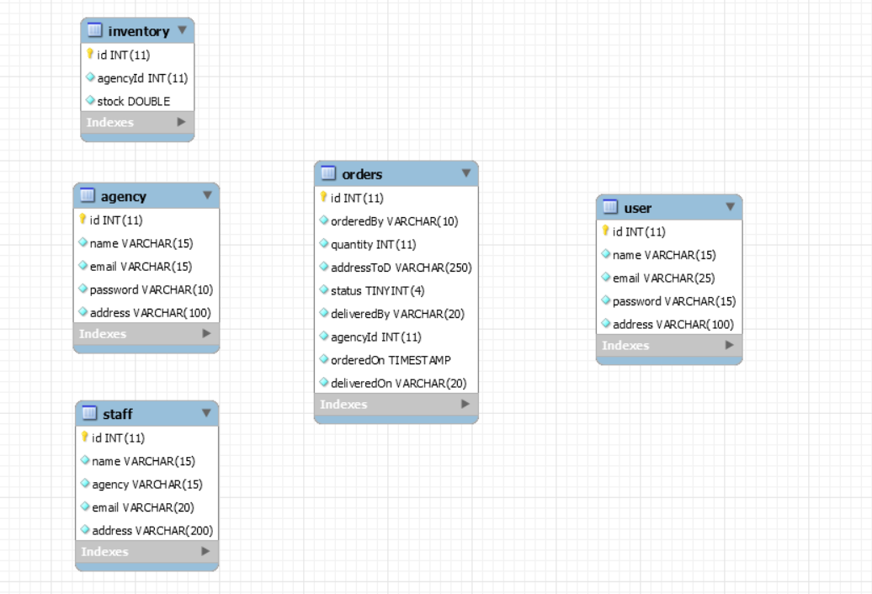

**Project Screenshots**:

Take the screenshots as per walkthrough video or based on your understanding of project.